Project Design Phase-II
Technology Stack (Architecture & Stack)

Date | 18-10-2022
Team ID | PNT2022TMID14132
Project Name | Inventory management for retailers
Maximum Marks | 4 Marks

Technical Architecture:
The Deliverable shall include the architectural diagram as below and the information as per the table1 & table 2
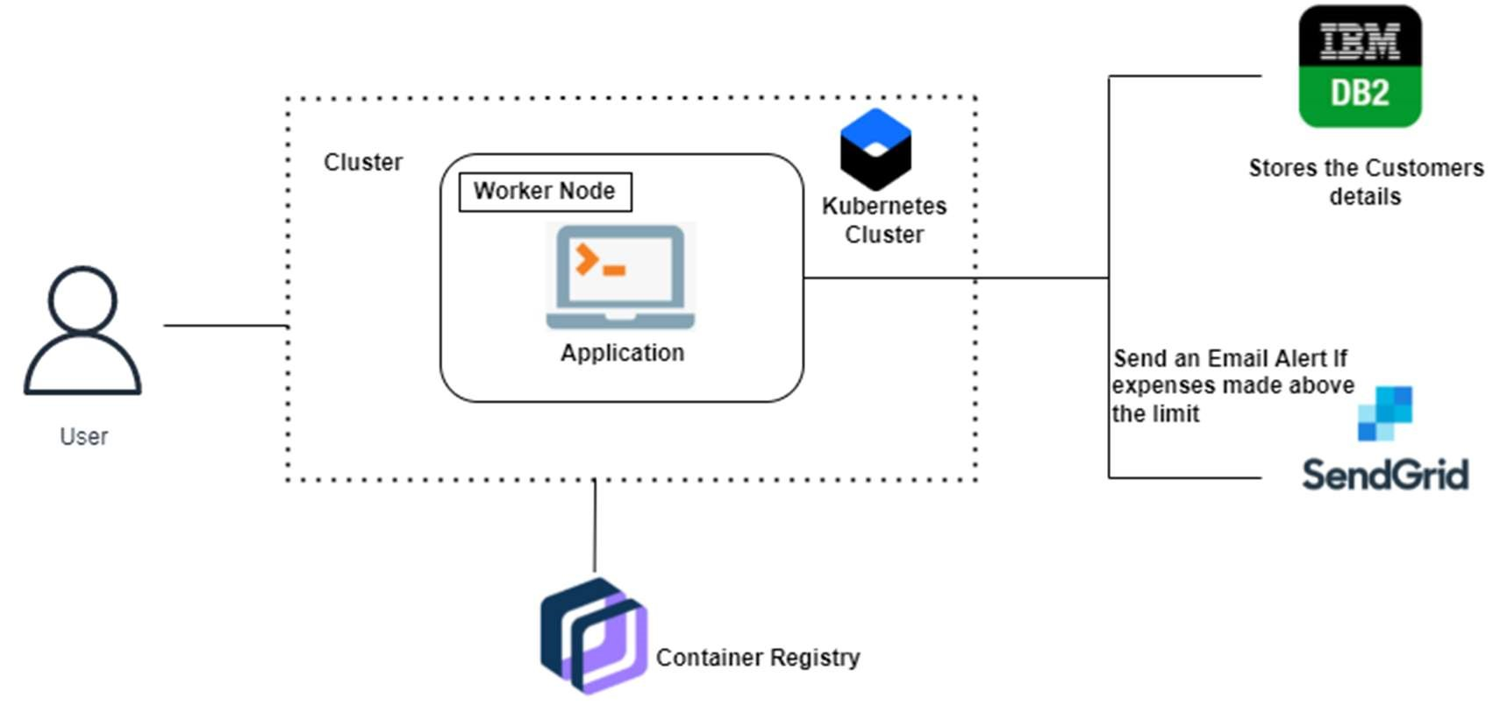

Table-1: Components & Technologies:
S.No | Component | Description | Technology
1. | User Interface | How the user interacts with application e.g. Web UI, Mobile App, Chatbot etc. | HTML, CSS, JavaScript, Python Flask, etc.
2. | User Login | User can able to login throw their email account. | Python Flask
3. | Graph Visualisation | Rendering plots and graphs based on the user spending data | Seaborn, Matplotlib
4. | Database | Data Type, Configurations etc. | MySQL
5. | Cloud Database | Database Service on Cloud | IBM DB2
6. | File Storage | File storage requirements | IBM Block Storage
7. | SendGrid | A cloud-based SMTP provider that allows you to send email without having to maintain email servers | SendGrid is used to trigger mail to user emails when a particular condition is met.
8. | Google OAuth | OAuth 2.0 allows users to share specific data with an application while keeping their usernames, passwords, and other information private. | Enables login through Gmail account, thus making the application accessible
9. | Infrastructure (Server / Cloud) | Application Deployment on Cloud | Cloud Foundry, Kubernetes, etc.

Table-2: Application Characteristics:
S.No | Characteristics | Description | Technology
1. | Open-Source Frameworks | Python-based Flask is a microweb framework. A microframework is what it is because it does not call for specific tools or libraries | Python Flask Framework
2. | Security Implementations | Python-based Flask is a microweb framework. A microframework is what it is because it does not call for specific tools or libraries | Use some of the crypto algorithms like rail fence transposition technique
3. | Scalable Architecture | Containerized application is deployed too rapidly increase scale on demand | Docker
4. | Availability | This application will be available to user at any point of time | Container Registry, Kubernetes cluster
5. | Performance | The performance will be high because the traffic will be less in the application | Kubernetes cluster

